PMP Automated Server Build Script (Windows 2008)
Author: Tao Yang
Date: 10/10/2008
Version: 1.0

Prerequisites:
- At least one NIC is connected to the switch and IP address assigned (also enter default gateway if applicable and subnet mask. Don’t need to enter DNS addresses as the script does it for you).
- Windows Powershell feature is turned on
  - To turn on Powershell, go to Server Manager, click on Add Features and select Windows Powershell.
- Windows Powershell Execution Policy has been set to Unrestricted:
  - By default, Execution policy is “Restricted” which means powershell scripts are not allowed to run. To check the current setting, use “Get-ExecutionPolicy” command.
  - In Powershell console, use “Set-ExecutionPolicy Unrestricted” command to the policy.
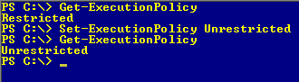
Note: To automatically enable PowerShell feature and set Execution policy, run “configure_powershell.bat” from the Build Scripts folder.
Instruction:
- Copy the “Build Scripts” folder to root C:
- In Powershell Console, change the location to the Build Scripts folder.
- Run the PMPSrvBuild.PS1 by entering “./PMPSrvBuild.PS1” and press Enter
  - Please note in Powershell, when running a script, we have to put in the absolute path, even the script is on the current directory. “./” or “.\” represent the current location.
  - Alternatively, use the auto completion function: start typing the script name and use Tab key to auto complete the name.
- Enter the Computer Name when prompted or press Enter to skip:
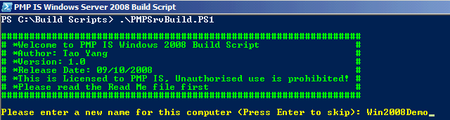
- After each script has finished running, it prompts on the script that it has finished:
- Below is a screen shot when reboot is required:
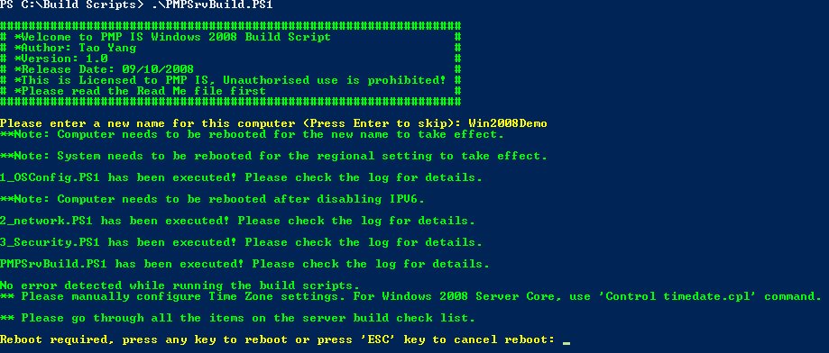
- Below is a screen shot when reboot is not required:
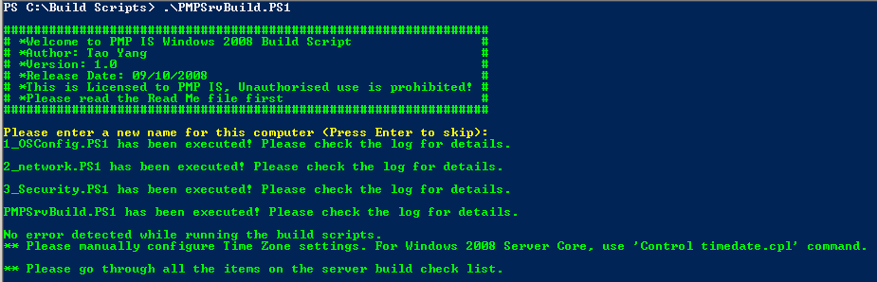
- If Computer name or Regional Setting has been changed, the script will prompt to reboot the computer.
  - At the prompt, press any key (except Esc key) and the computer will reboot (no need to press enter).
  - Press Esc Key to cancel reboot (no need to press enter after Esc key).
- If all scripts finished successfully, below message appear on the screen:
Otherwise, an error message shows on the screen:
Things covered in the script:
- Owner Name and Organisation: PMP Limited
- Startup and Recovery Options:
  - Disable Send Admin Alert
  - Enable Auto Restart
  - Mem Dump 64K
- Boot Menu time-out changed to 5 seconds.
- Network Config
  - Rename any Network Connections with a name contains “Local Area Connection”
  - Active Network Connections will be renamed to “Active_#” followed by a sequential number then the network address:
    - i.e. if the network is 10.61.14.0 (255.255.255.0) and it is the first nic, connection name will be Active_#1_10.61.14.0
    - i.e. if the network is 192.168.1.192 (255.255.255.192) and it is the second nic, conncetion name will be Active_#2_192.168.1.192
  - Unused connection will be renamed to “Unused_#” followed by a sequential number.
  - Disable all Unused network connections.
- Name Resolution
  - Set DNS servers to 10.61.14.40 and 10.21.31.30
  - Set DNS Suffix Search Order
  - Disable LMHOST lookup
  - Disable IPV6
- Time Sync
  - Set the NTP server to pmpdom-1.pmplimited.com.au (HKLM\SYSTEM\CurrentControlSet\Services\W32Time\Parameters\NtpServer)
    - Make sure to manually change it to clatime or pmpext-2 if the server is located in Extranet or DMZ
    - This ensures standalone servers have a valid time sourceWhen the server joins to the domain, it set time sync to NT5DS therefore the NTP server is ignored.
- Windows Services Disabled:
  - Remote Access Auto Connection Manager
  - Remote Access Connection Manager
  - Routing & Remote Access
  - Telephony
- Event Log Requirements
- Misc
  - Enable Remote Desktop
  - Screen Saver
    - Enabled
    - Screen Saver: logon.scr
    - Screen Saver password lock
  - Disable Windows Animation
  - Auto end hung app at shutdown
  - Change “My Computer” to computer name
  - Always show network connection icon @ system tray
  - Use Classic Startup Menu
- Security
  - Audit settings
  - Rename Admin account
  - Rename and Disable Guest Account
  - Legal Notice
  - Assign password to Guest account
  - Disable Windows Firewall
- Regional Settings for all users
  - Set to use Australia locale for all users.
Things are not covered in the script:
- Startup and Recovery Options:
  - Recovery Console Install
- Network Config
  - NIC Power Management
  - Time Zone configuration (So far cannot find a way to do so via a script or command)
  - Vendor specific NIC teaming software
- Security
  - Local admin password reset (due to security reason that don’t want to place the admin password in clear text in the script)
- Others
  - Pagefile configuration
  - Dynamic disk conversion

